DAM LEVEL MONITOR

TEAM NAME : A.I.Q

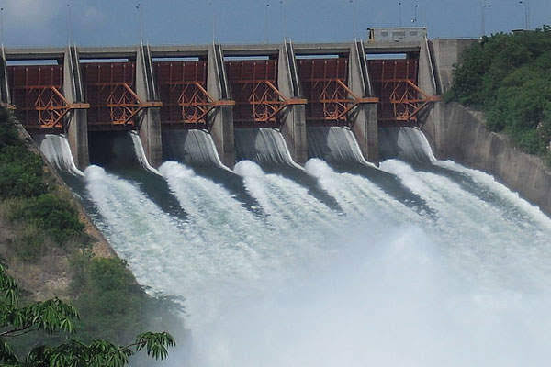

TEAM MEMBERS:

1.Anusha goli(19h61a12e0)

2. Sai Akshaya(19h61a12c7)

3.Tanmayee (19h61a12h2)

4.Supriya(19h61a12h8)

Introduction and Aim of the project:

We propose an automatic dam water level monitor and gate

opening application using IOT . The basic idea is to describe

possibilities of IOT applications in dam monitoring and safety. Here

sensor is used to sense the water level and then the dam gates are

opened when the water reaches a particular level. The sensor is

used to measure at three different levels to check the water level

and provides alert accordingly. When the water level reaches the

first sensor, it is sensed an alert is given to the authorities and 2

gates are opened and when it reaches the second higher level, then

4 gates are opened. When it exceeds third or final water level, an

alert is given such that all gates are opened(ex:6)and the sensor

provides a signal and the dam gates are open automatically.It also

sends a caution to the nearby people to vacate the place

immediately.

FLOWCHART:

Here we are showing how many gates are opened when the water level increases from 0m to 1000m.

WORKING:

We are using ibm cloud app to create an internet of things platform and we connected the Dam level monitor device to the platform and created an application on how water sensors are connected and when they are alerted. We used 3 water sensors at 500m level, 700m level and 900m level respectively. So when water level reaches each sensor 2,4,6(max) dam gates are opened respectively. When maximum gates are opened then we used fast2sms app to send a message to the authorities and nearby villages grampanchayat.

DAM LEVEL MONITOR DEVICE

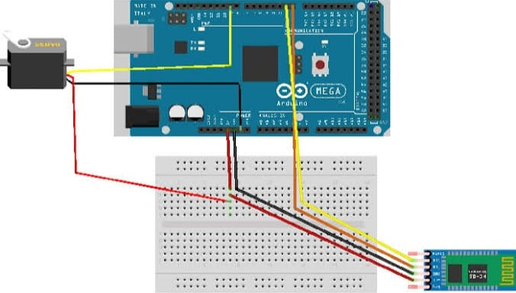

APPLICATIONS:

• By using this idea we can reduce the man power

required at each and every dam . Since this is a

fully automated project, any kind of human

activity can be avoided. So the possibility of

faults can also be decreased.

• During times of natural disaster like floods this automatically alerts the people and authorities.

We can record the real time data in the automation application. Also by comparing with dam prototype, this idea can be implemented in existing dams.